REPORT WRITING:
The report should be started with the “TITLE”. The title includes:
. The name of the person to whom the report is written
. The designation of the person
For example:
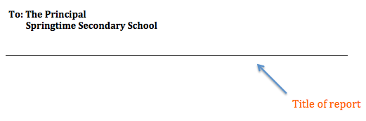

In the second part of the report, (Just below the title of the report) introduce yourself and state the purpose of report. Four “W’s” need to be stated in the first paragraph:
. What: describe the incident as you experienced it or as it was told to you by those
involved.
. Where: the location of the incident.
. When: note dates and times.
. Why: relate statements of others, but do not write your own opinions. Many times the
why of an incident is unknown.

Subsequent paragraphs:
This should be followed by subsequent paragraphs highlighting the series of events in a chronological sequence.
Ending:
The ending should contain a general comment, e.g, The police is still continuing its investigations.
Then end the report as follows:
Reported by: ____________________
Signature: ______________________
Date: __________________________

